Guardian Angels
Job Description
POSITION TITLE: Direct Care Worker
RESPONSIBILITIES:
- Maintain accurate documentation
- Obtain information and interpret information in terms of residents
- Interact directly with residents
- Assist in planning and executing group, program, and recreational activities
- Serve meals to each resident according to the menu
- Always supervise residents
Maintain work environments free of recognized hazards. Provide care, welfare, safety, and security for residents.
- Provide transportation to the residents for appointments as needed
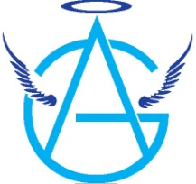
- Ensure daily the safety and cleanliness of all areas of the program. Adhere to all regulations and standards necessary to meet licensing and accreditation compliance
- Complete a minimum of 50 hours of in-service training hours annually in child care services, excluding first aid and orientation
- Participation in the Performance Appraisal process, including a review of your Job Description
- Other duties as assigned

EXPERIENCE:
- Work with diverse populations
- Ability to monitor behaviors and document observations effectively
- Effective usage of computers

The Direct Care Worker reports to the Shift Lead, Shift Supervisor, Staff Supervisor, and Licensed Child Care Administrator.

Minimum Qualifications
- Must be at least 23 years old
- High school diploma or equivalent
- Must work a minimum of 40 hours per week
Salary
Commensurate with skills & experience
Stipends available after the probationary period
Growth opportunity with the company

