Guardian Angels
Job Description
POSITION TITLE: Direct Care Worker
RESPONSIBLITIES:
- Maintain accurate documentation
- Obtain information and interpret information in terms of residents
- Interact directly with residents
- Assist in planning and executing group, program and recreational activities
- Serve meals to each resident according to menu
- Supervise residents at all times
- Maintain work environments free of recognized hazards. Provide care, welfare, safety and security for residents
- Provide transportation to the residents for appointment as needed
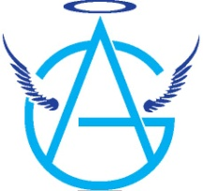
- Ensure on a daily basis the safety and cleanliness of all areas of the program. Adhere to all regulations and standards necessary to meet licensing and accreditation compliance
- Complete a minimum of 50 hours of in-service training hours annually in child care services, excluding first aid and orientation
- Other duties as assigned

EXPERIENCE:
- Work with diverse populations
- Ability to monitor behaviors and document observations effectively
- Effective usage of computers

The Direct Care Worker reports to the Shift Lead, Shift Supervisor, Staff Supervisor and Licensed Child Care Administrator.

Minimum Qualifications
- Must be at least 18 years old
- High school diploma or equivalent
- Must work a minimum of 40 hours per week
Salary
Starting at $9.00 per hour
Commensurate with skills & experience
Stipends available after probationary period

